Loom video link
https://www.loom.com/share/05fc48f18722464ba78bddfdb849bae4?sid=96b1cf42-bffc-48a9-8d52-8379218d5ef9
Reflection (3–5 sentences)
Notable changes are below. Create an event application for United Stars for the Upstate (USU). USU is a volunteer organization where workers help out with concession to help pay for their children’s sport or education activities. This app allows the volunteers to sign up for available events and the administrator can also add upcoming events. Limitations right now of the app is that it does not track sign on, so the information regarding sign up is currently tied to the event. Future versions of this app could include a separate table `signup` that would hold user along with event id signed up for.
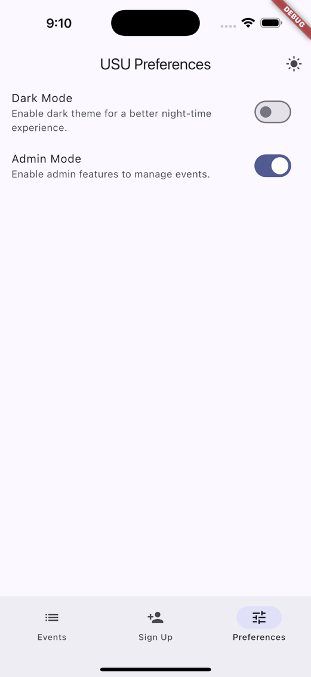
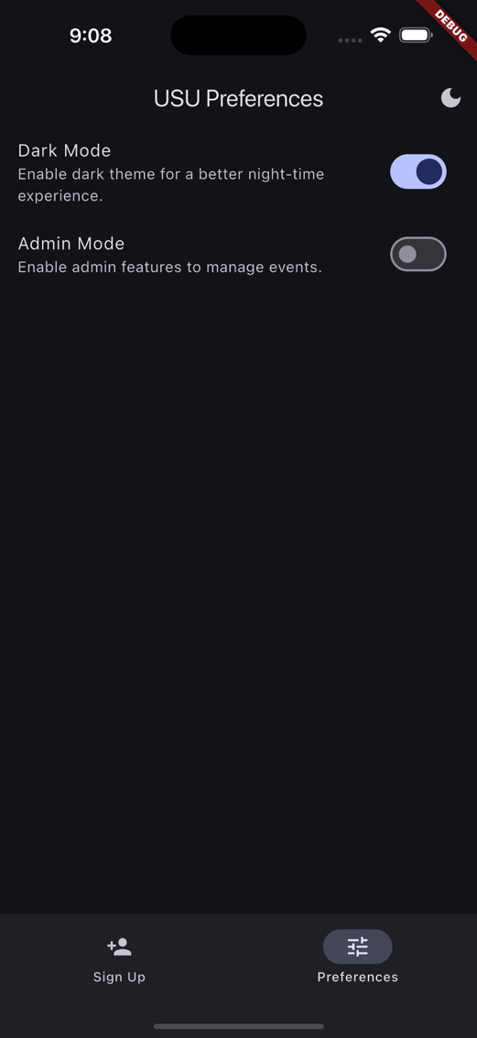
The application uses `shared_preferences` to toggle two modes (e.g. Dark, Admin). Dark Mode allows the user to toggle the light/dark theme for the application and Admin Mode toggle the Events screen to show allowing and admin to enter/modify events for the organization.
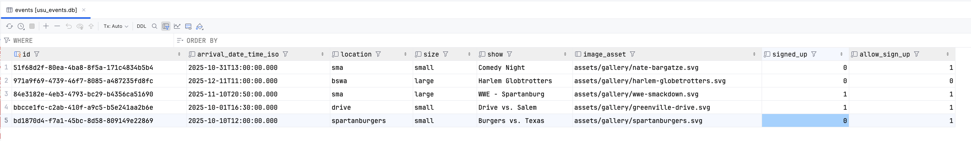
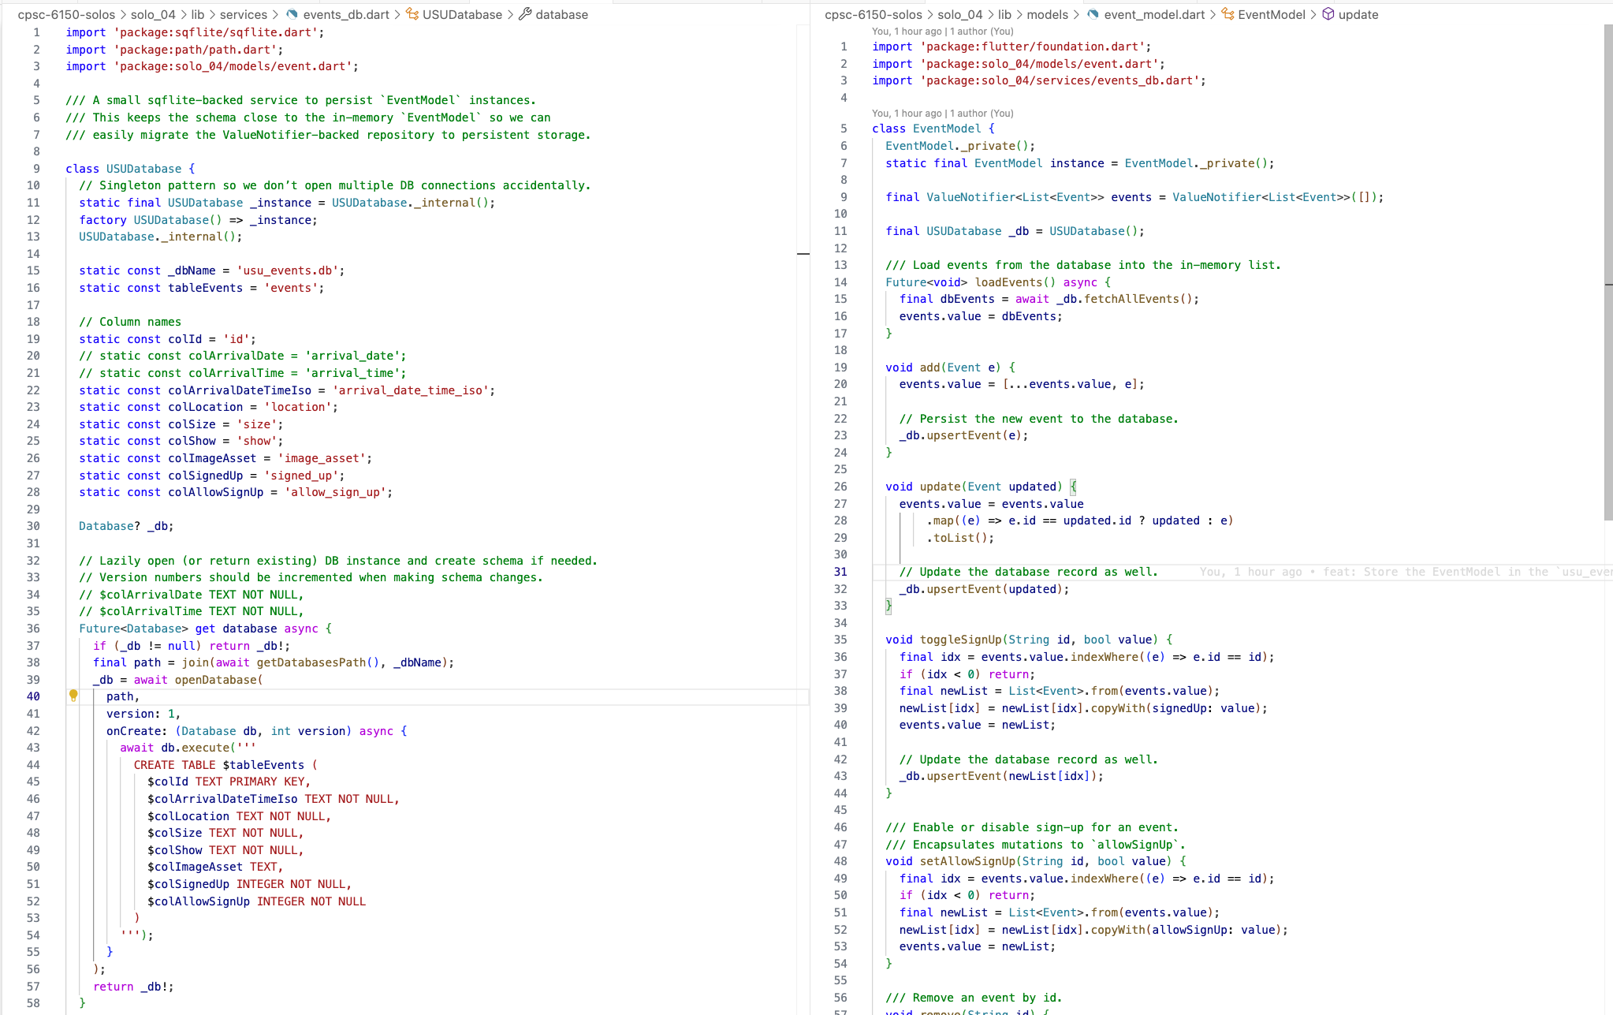
I used SQLite to store the Event instances into a `usu_events.db` which was managed USUDatabase class. This class had methods to insert/update Event records, retrieve all Event records on initState(), and delete Events per id. The EventModel class was used to instantiate this USUDatabase() and be the main accessor to the database through the UI Widgets.
SQLite `events` table was used to house the Events metadata. Each event used a UUID value for uniqueness. Most of the other field values were entered in from the EventForm screen. For the next version of this app, the `signed_up` field needs to be moved to another table `signups` that will capture user and their corresponding signed up events.
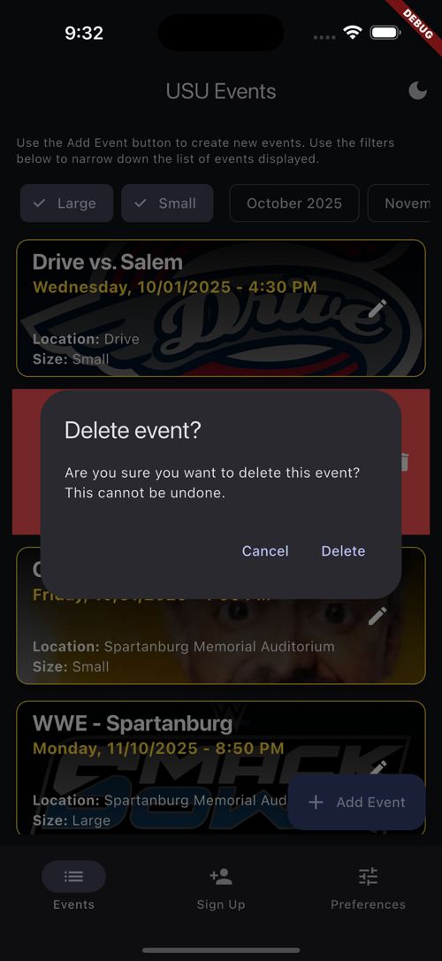
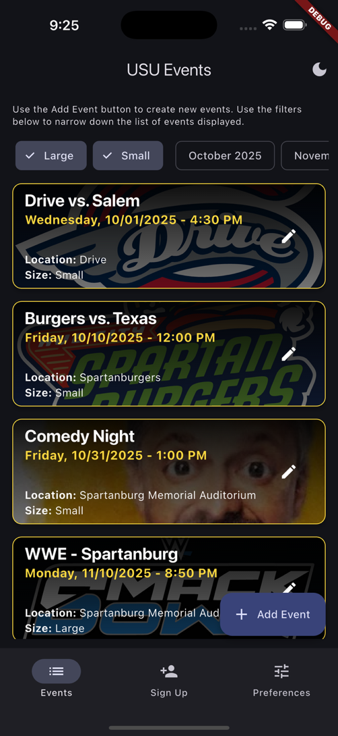
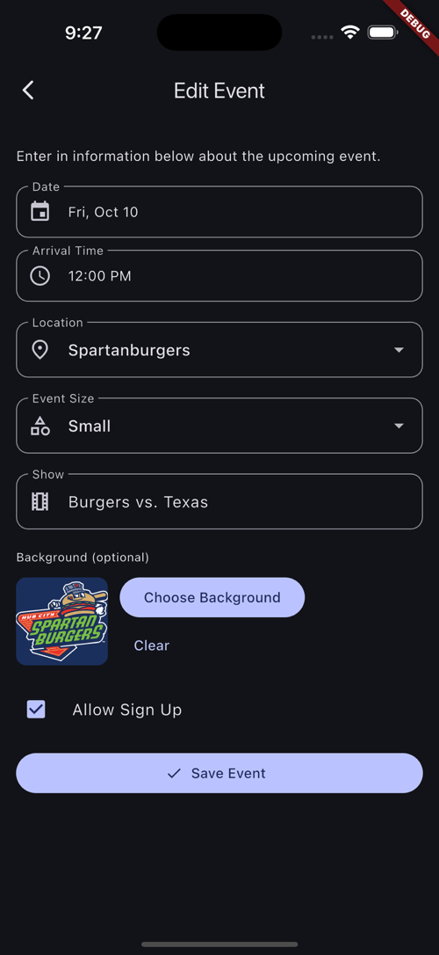
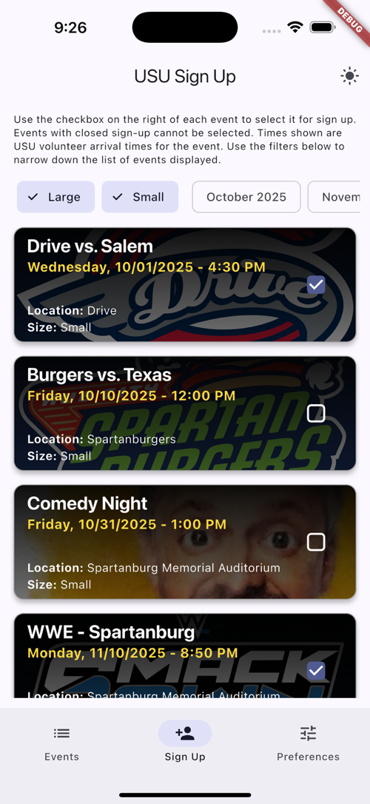
Here are the different screens for the application. The Events screen shows only for the Admin Mode and allows the admin to add/modify events. Admins can swipe to delete the event (shown in the bottom image). The Edit Event screen allows the admin to modify details for the event, changing date, arrival time, location, size, show name, and background image. Far right, the Sign Up screen allows the volunteers to check which event they would like to work.

Code Repo
https://github.com/ztraboo/cpsc-6150-solos/tree/assignment-solo-4/solo_04

